Dear Parent/carer
Please find below a brief description with screen shots as to how your child can find relevant work in the event of an absence from school should you wish to support them with this.
- Your child should visit the Academy’s website where they will find in the top right corner the tab – Home Gateway.
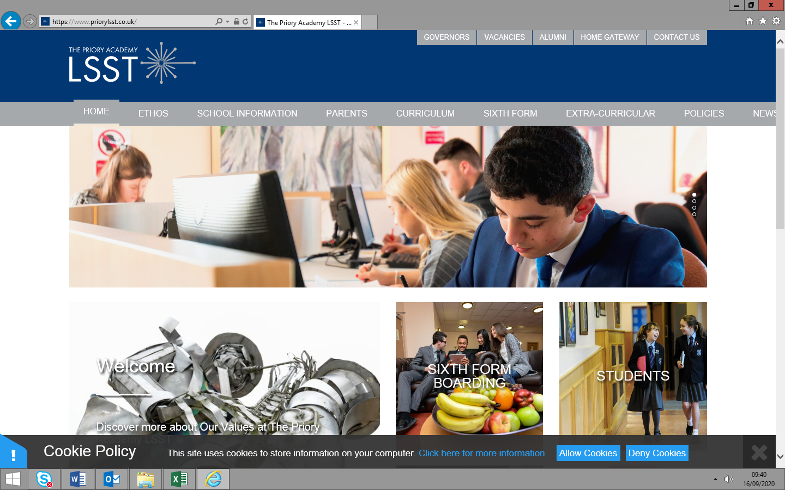

- Once into the home gateway they will see the button allowing them access to their desktop.

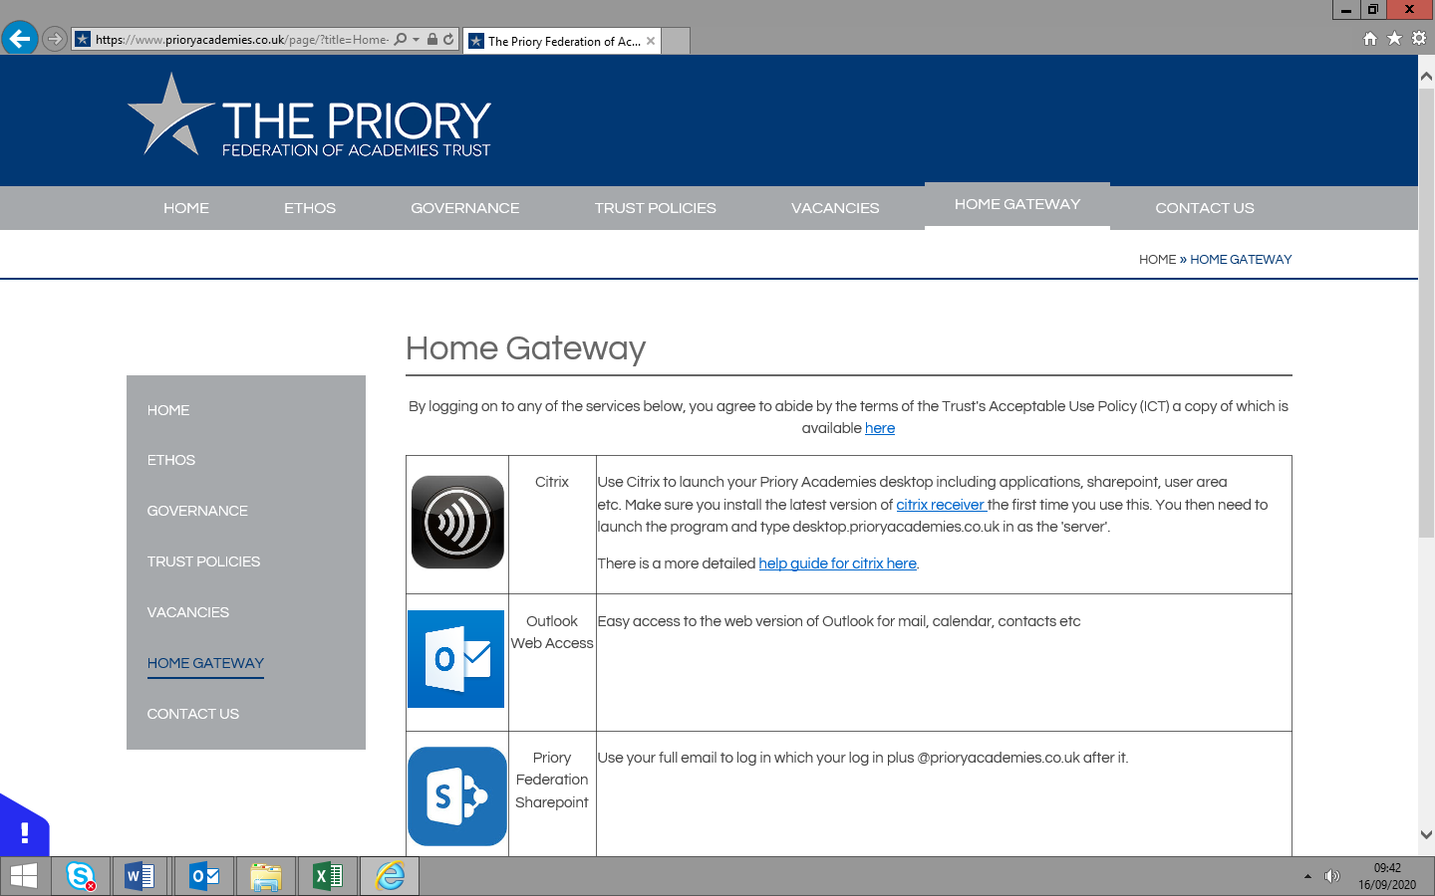

- Your child should then login to Citrix with their log in details (the students unique P number and password). We recommend the app version of Citrix which can be downloaded using a link on the Home Gateway page of the Academy website.
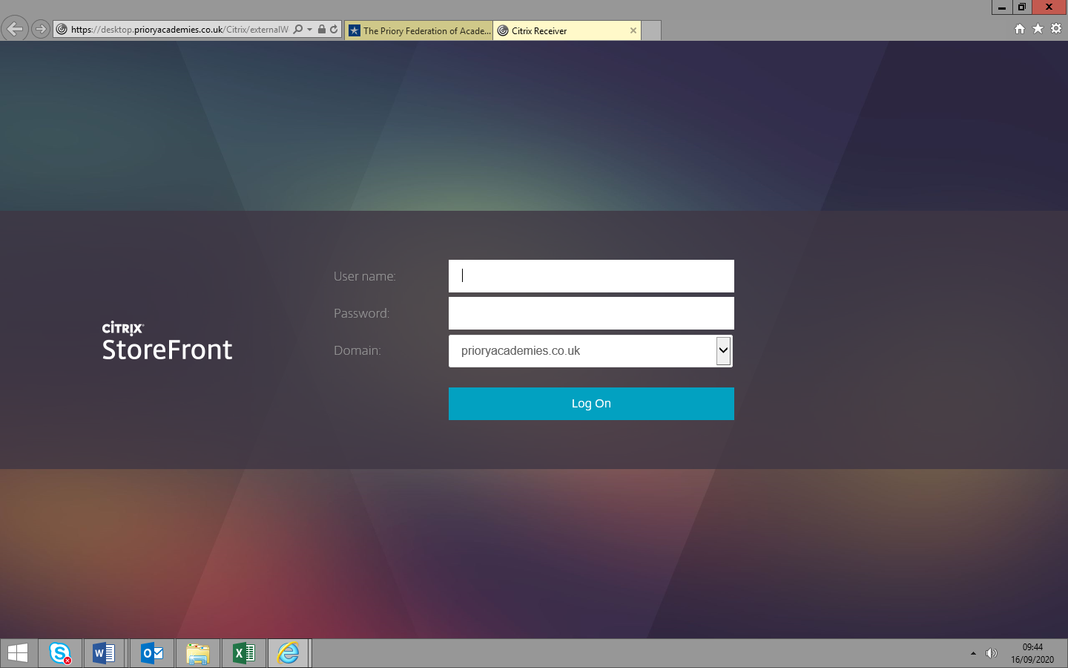

- Once into the system the student should click select either Internet Explorer or Chrome and then press the LSST logo to access our SharePoint page
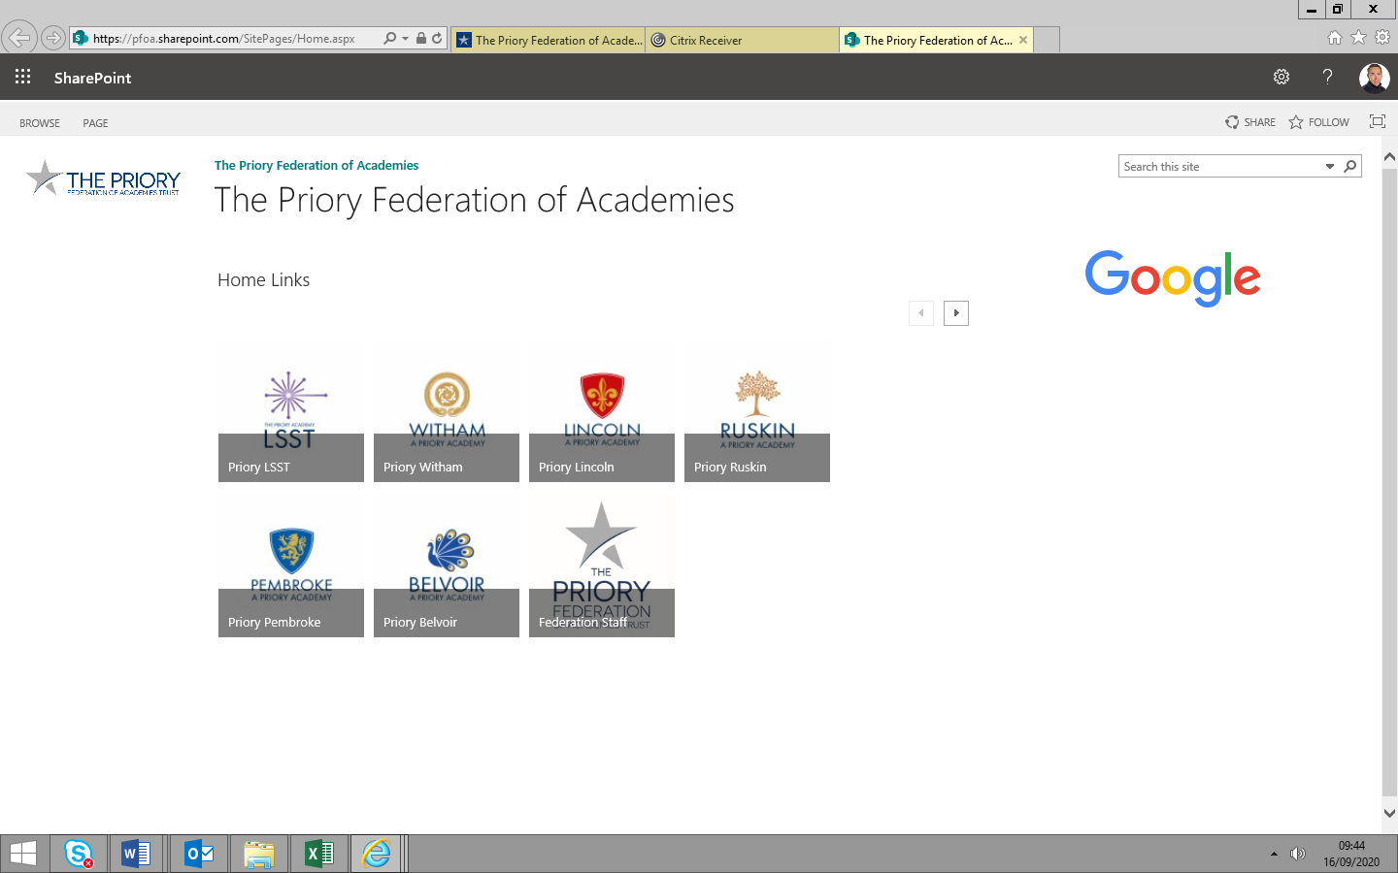

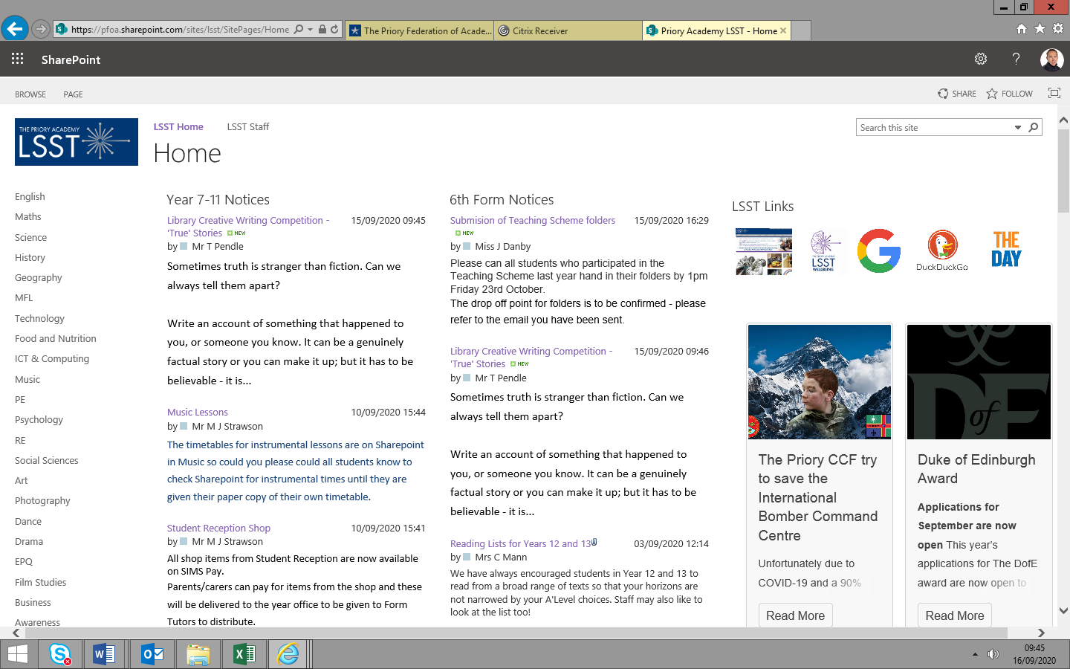
- The SharePoint homepage will give access on the left hand side to each subject area

- From there they should choose the member of staff from the list on the left hand side.
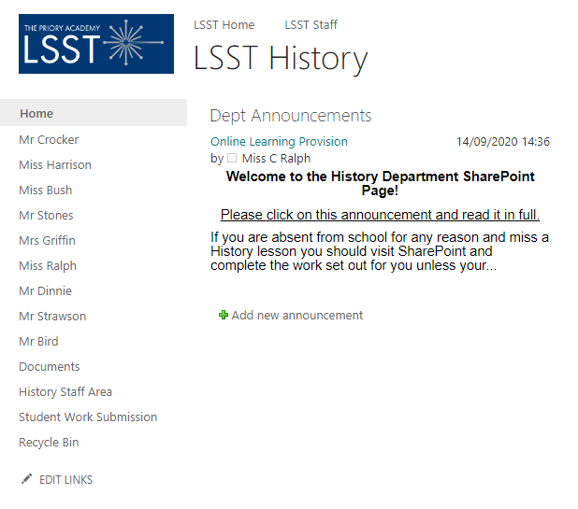
- There will then be instructions and information to access the relevant work from their teacher.

