The Priory Academy LSST

Extra-Curricular Activities
Module 1

This Priory Academy LSST extra-curricular activities booklet details opportunities on offer to students outside lesson time. The full range of activities on offer will be updated and available on the website each module.

These range from sporting activities such as football, rugby and netball to learning new skills within nationally recognised schemes such as CCF and Duke of Edinburgh.

The House System offers a variety of activities for all year groups. Every module we offer a sports competition for each year group. Although they are hotly contended, the competitions are inclusive and friendly; students are encouraged to take part no matter what their level of competence in a sport may be.

We also regularly launch design competitions which link in with seasonal themes and have a school wide focus. Students could be asked to design a banner to represent their House on Sports Day.

Major events are run at key points of the year in conjunction with The Priory Association including The Talent Show.

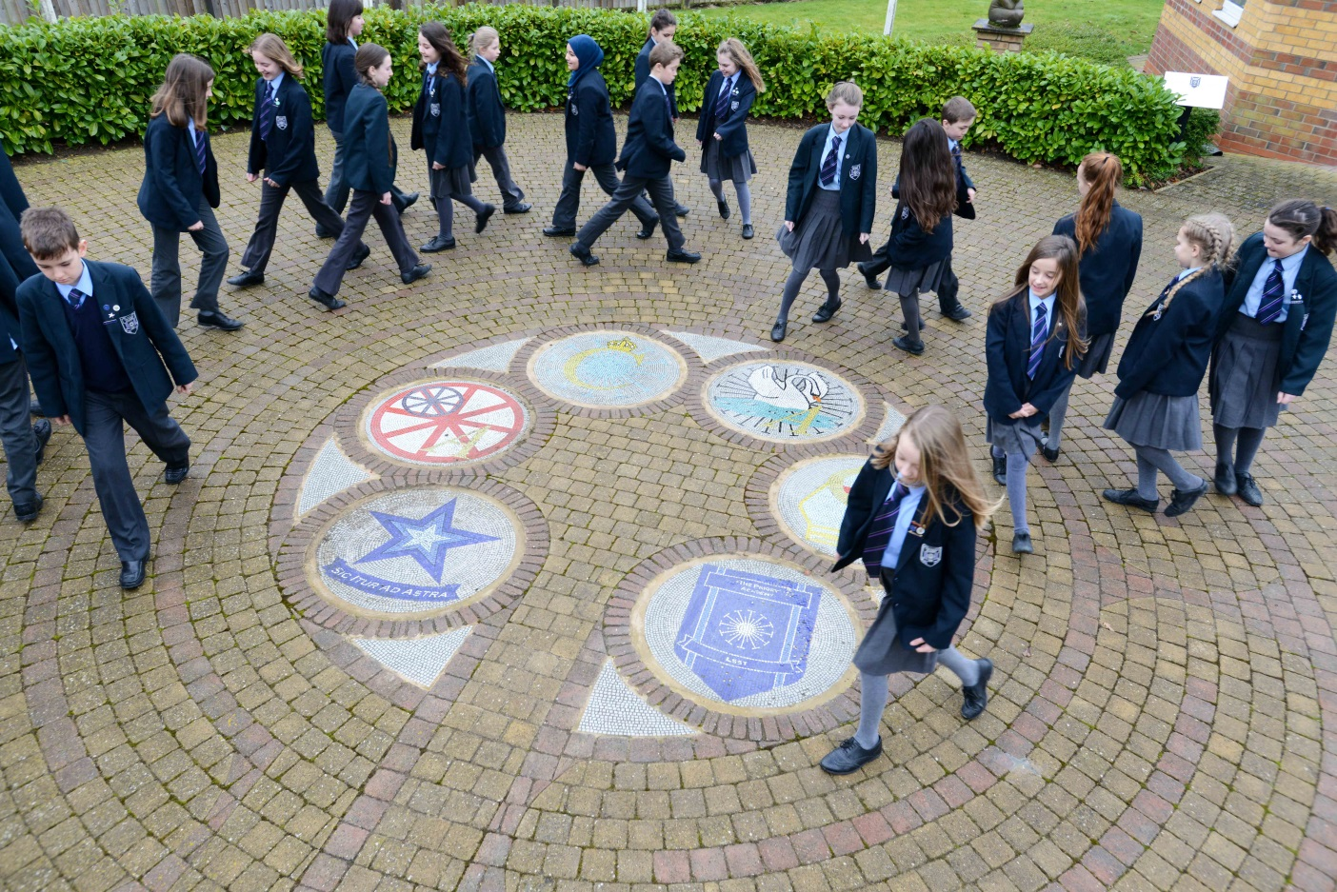

We aim to involve all students in positive, engaging, competitive activities which are intended to develop their physical, social, and intellectual skills.

Please browse the following pages for a full list of activities

Monday

Activity | Where? | Who? | Which staff?
Breakfast Club  8.00 – 8.20 | Main School Canteen | All Years | Mrs G Avis
Priory Jazz Band  12.20 – 12.50 | MU2 | All Years | Mr Whitworth
Fantasy Gaming Club  3.05 – 4.00 | Library | All Years | Mrs J Coggan
Canoe Club  3.05-4.30 | Pool | All Years | Mr P Brazinskas/  Mrs K Bentley
Homework Club  3.15 – 4.00 | U26/L75 | Year 7 - 9 | Mrs R Lockley
Badminton Club  3.05 – 4.30 | Sports Hall | All Years | Mr Gibbard
Rugby Club  3.05 – 4.30 | Rugby Pitch | 6th Form | Mr J Whittaker
Priory Leisure  3:05-6pm | Fitness Suite /Track | Priory Leisure Members | Mrs E French/ Mr L Treadwell/ Miss A Lilley

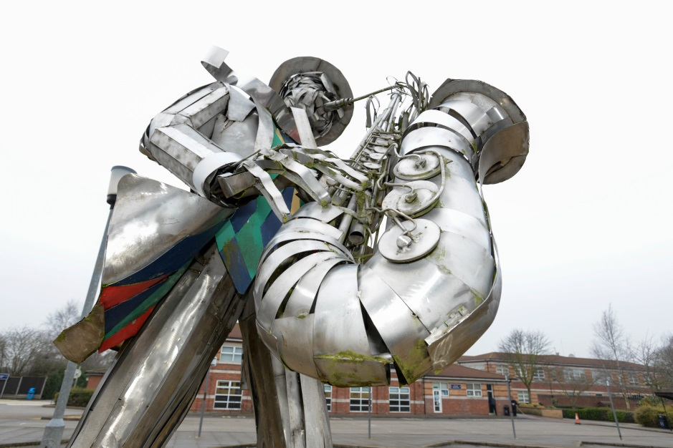

Tuesday

Activity | Where? | Who? | Which staff?
Breakfast Club  8.00 – 8.20 | Main School Canteen | All Years | Mrs G Avis
Boys’ Choir  8.20 – 8.50 | MU2 | Year 7 - 9 | Mr S Billinger
KS3 Photography Club  3.15 – 4.15 | Q36 | Year 7 - 9 | Mrs M Alexander
KS3 Art Club  3.15 – 4.15 | Q6 | Year 7 - 9 | Mrs M Alexander
KS4 Art Study Group  3.15 – 4.15 | Q13/Q19 | Years 10 & 11 | Mrs C Thomas
Homework Club  3.15 – 4.00 | U26/L75 | Year 7 - 9 | Mrs R Lockley
Swim Academy  3.15 – 4.15 | Swimming Pool | All Years | Mrs E French
Priory Leisure Swim  3.15 – 4.30 | Swimming Pool | Priory Leisure Members | Mrs E French
Netball Club  3.05 – 4.30 | Sports Hall | Squads | Mrs Porter
Rugby Club  3.05 – 4.30 | Rugby Pitch | Year 8 - 11 | Mr P Brazinskas
Girls Rugby  3.05 – 4.30 | Rugby Pitch | All Years | Mr C Moran
Combined Cadet Force  3.20 – 5.40 | 6th Form | Year 9 - 13 | Mrs C L Thompson
Cooking Club  3.15 – 4.15 | L34 | Year 7 | Mr D Goffe
Priory Leisure  3:05-6pm | Fitness Suite /Track | Priory Leisure Members | Mr L Treadwell/ Miss A Lilley

Wednesday

Activity | Where? | Who? | Which staff?
Breakfast Club  8.00 – 8.20 | Main School Canteen | All Years | Mrs G Avis
String Ensemble  8.20 – 8.50 | MU1 | All Years | Mrs E Ward-Caddle
Junior Girls’ Choir  12.20 – 12.50 | MU1 | Year 7 - 9 | Miss H Smith
Christian Union  12.30 – 12.50 | L22 | All Years | Mr M Smailes
Climbing Wall  3.05 – 4.30 | Climbing Wall | All Years | Mr Brazinskas
Homework Club  3.15 – 4.00 | U26/L75 | Year 7 - 9 | Mrs R Lockley
Art Study Group  3.15 – 4.15 | Q13/Q19 | Year 10 & 11 | Miss L Johnson
Priory Press  3.15 – 4.15 | Q7 | All Years | Mrs S Wilkinson
4 X 4 Club  3.15 – 4.15 | L46 | Year 10 & 11 | Mr L Whitehead
Debating Club  3.15 – 4.30 | Debating Chamber | Year 10 - 13 | George Baker
Scuba Club  3.15 – 5.30 | Swimming Pool | All Years | Mrs E French
KS4 Art Study Group  3.15 – 4.15 | Q13/Q19 | Years 10 & 11 | Miss L Johnson
Vex Robotics Club  3.20 – 4.15 | Tech Concourse | Year 11 & 12 | Mr R Jones
Trampoline Club  3.05 – 4.30 | Sports Hall | All Years | Coach
Netball Club  3.05 – 4.30 | Sports Hall | Year 7 & 8 | Mrs Porter/Bentley
Netball Trials  3.05 – 4.30 | Sports Hall | Year 7 | Mrs Bentley
Recreational Netball  3.05 – 4.30 | Sports Hall | All Years | Miss K Nicholson
Football Club  3.05 – 4.30 | Sports Field | Year 7 & 8 | Mr D Fearn
Young Enterprise  3.15 – 4.30 | U35 | Year 12 | Mrs R Cavill
Rugby Club  3.05 – 4.30 | Sports Field | Under 18’s | Mr P Brazinskas
Priory Leisure + Personal Training Sessions  3:05-6pm | Fitness Suite /Track | Priory Leisure Members | Mr L Treadwell/ Miss A Lilley
Thursday

Activity | Where? | Who? | Which staff?
Breakfast Club  8.00 – 8.20 | Main School Canteen | All Years | Mrs G Avis
Senior Girls’ Choir  8.20 – 8.50 | MU1 | Year 10 - 13 | Miss H Smith
History & Archaeology club  12.20 – 12.50 | H2 | All Years | Miss J Harrison
Woodwind Group  12.20 – 12.50 | MU2 | All Years (Grade 3 required) | Mr D Thaxter
Chess Club  3.05 – 4.00 | Library | All Years | Mrs E Allan
Homework Club  3.15 – 4.00 | U26/L75 | Year 7 - 9 | Mrs R Lockley
Philosophy Club  3.15 – 4.30 | R1 | Year 9 - 13 | Mrs K Stephens
Swim Academy  3.15 – 4.15 | Swimming Pool | All Years | Mrs E French
Priory Leisure Swim  3.15 – 4.30 | Swimming Pool | Priory Leisure Members | Mrs E French
Level 2 Sports Leaders  3.15 – 4.30 | I. Track | Year 10 | Mrs Porter
Vex Robotics Club  3.20 – 4.15 | Tech Concourse | Year 11 & 12 | Mr R Jones
Badminton Club  3.05 – 4.30 | Sports Hall | All Years | Mr Gibbard
Rugby Club  3.05 – 4.30 | Sports Field | Year 7 & South Africa Squad | Mr P Brazinskas
Priory Leisure  3:05-6pm | Fitness Suite /Track | Priory Leisure Members | Mr L Treadwell/ Miss A Lilley

Friday

Activity | Where? | Who? | Which staff?
Breakfast Club  8.00 – 8.20 | Main School Canteen | All Years | Mrs G Avis
Chamber Choir  12.20 – 12.50 | MU2 | Selected Vocalists | Mr S Billinger
Worldwise Geography  Alternate Fridays  12.30 – 12.55 | G4 | Year 7 | Miss K Tunnard
Basketball Club  3.30 – 4.30 | New Sports Hall | 6th Form Boys | Mr B Smith/Mr T Barker
Priory Leisure  3:05-6pm | Fitness Suite /Track | Priory Leisure Members | Mr L Treadwell/ Miss A Lilley

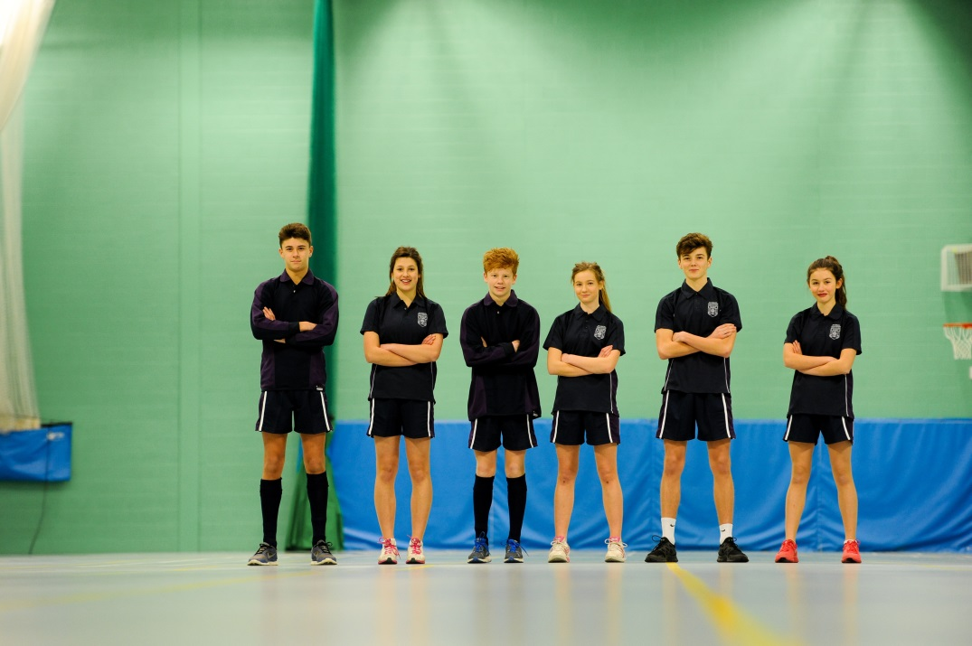

Priory Leisure
2016-2017

Priory Leisure gives students and staff the opportunity to unwind, exercise, socialise and keep fit and healthy in a relaxed environment.
Students have access to the fitness suite and running track along with expert advice from our Fitness Instructors and Personal Trainers

MEMBERSHIP Includes:

TUES/THURS 3:15-4:15PM
Use of:
• SWIMMING POOL
For lane swimming or recreational aqua fun
MON-FRI 3-6PM
Access to:
• FITNESS SUITE
• PERSONAL TRAINING SESSIONS
• OUTDOOR TRACK

+

Membership Options:
ANNUAL-£70
(Valid up 14TH July 2017)
or
Pay As You Go- £3.50 per week
(Valid up to the Friday of the week paid in)

Available Term time only
Pay at Student Reception or at the Fitness Suite
Health questionnaire must be completed before commencement

